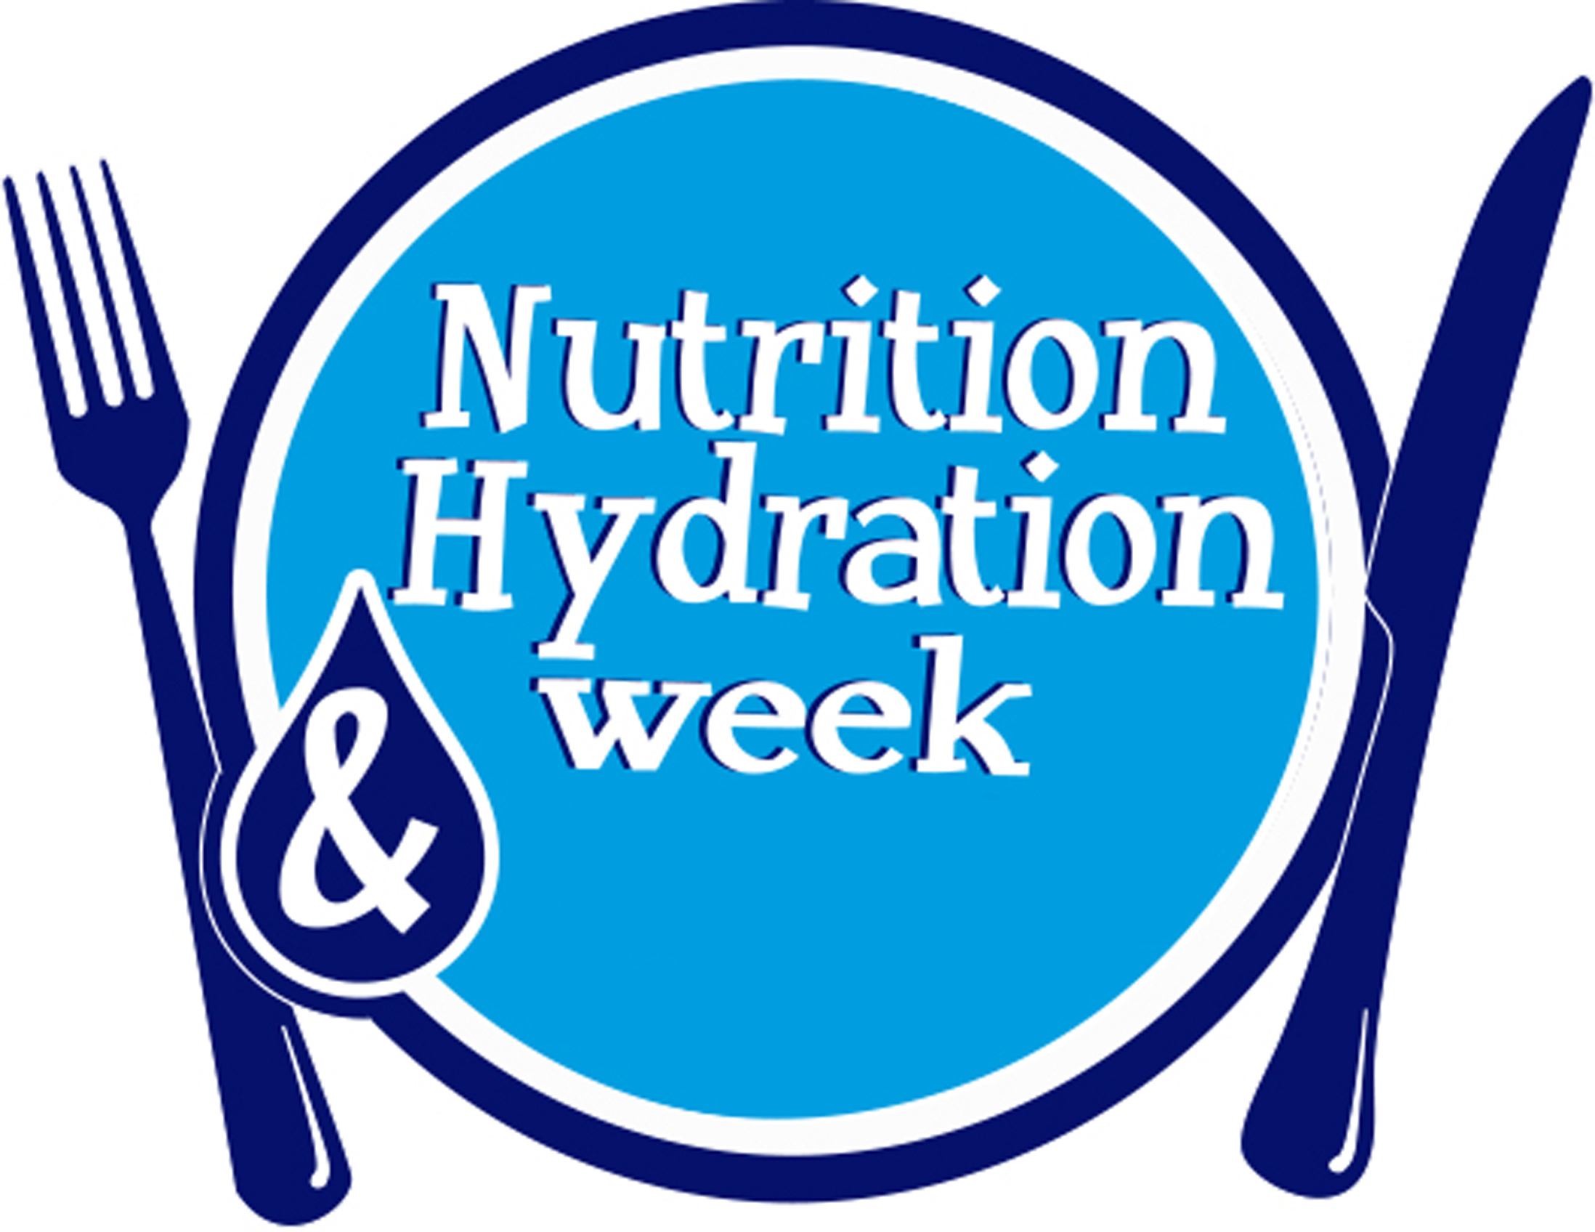 TM Pending

Nutrition and Hydration Week

Continual Education and Professional Development

Personal Record Form

Period Commencing 1st January 20___ to 31st December 20____

Name: __________________________

Address: ____________________________________________________________________________

Date | Describe the activity undertaken | Type of learning activity e.g work based learning, professional activity | Hours
03 June | I attended the Europe Hydration Institute conference | Formal/education | 6
 | Refer to category details on reverse | Total hours

Examples of Continuing Education and Professional Development activities

 | Type | Activity | Nutrition and Hydration Week Examples
1. | Work based learning | Learning by doing  Undertaking an audit  Being a representative on a committee  Work shadowing  Visiting another department | Audit your nutrition screening and fluid balance charts  Audit your texture modified meals  Audit your meal service with 2 of your colleagues and feedback your positive and negative observations  Become a member of your organisations nutrition committee  Join a special interest group in your professional association  Shadow your catering manager/ward manager/matron for a day  Visit your catering and/or dietetic department  Visit your community meals provider
2. | Professional activity | Involvement in a professional body/association  Attending branch meetings  Giving a presentation at a conference or forum | Become a member of the NACC or HCA (if you are not already)  Join the National Nutrition Nurses Group  Go along to a branch meeting  Give a presentation on what you and your organisation are doing for Nutrition and Hydration Week  Become a Nutrition and Hydration Week Ambassador
3. | Formal/  education | Courses  Attending conferences  Writing articles or papers  Planning or running a course | Attend a nutrition/hydration conference or forum  Write a case study about what you have done for Nutrition and Hydration Week (share with the Nutrition and Hydration Week team for inclusion in the website)  Write an article about Nutrition and Hydration Week and what it means to you and your organisation for professional journal  Plan a series of nutrition/hydration related training sessions for your organisation  Organise a local Nutrition and Hydration Week event
4. | Self-directed learning | Reading journals or articles  Updating knowledge through the internet or TV | Join one of the Nutrition and Hydration Week twitter chats
5. | Other | Public service  Voluntary work  Courses | Volunteer to help with a local care homes Nutrition and Hydration Week tea party

