Nutrition and Hydration Week’s mission is…

To create a global movement that will focus energy, activity and engagement on nutrition and hydration as a fundamental element of maintaining the health and well-being for our global community.

Introduction

Nutrition and Hydration Week has taken place every March since 2012.

With around 3 million people at risk of malnutrition in the UK and over 25 million in the G8 countries we need to engage opportunities to raise the awareness of the risks and promote the good practices that can help prevent malnutrition and dehydration. Preventing malnutrition and dehydration improves health and well-being and helps to reduce the burden on the health and social care services in treating and supporting those suffering from under nutrition and dehydration.

Nutrition and Hydration Week is a social movement that reaches out to health and social care professionals in clinical, nursing, catering and care situations utilising their expertise to bring you a great campaign you can get on board with in your organisation.

As the public health environment becomes more challenging with even tighter budget constraints coming into place Nutrition and Hydration Week is one of the most cost-effective health interventions possible.

Nutrition & Hydration Week keenly promotes the following:

- The 10 Key Characteristics for Good Nutritional Care
- Protected Mealtimes
- Nutrition Advocates for each health or social care setting
- The minimum standards for good nutrition in the respective settings
- Highlighting Good Nutrition and Hydration Practices
- Continued Education for professionals on good nutrition and hydration
- Plus, we would like everyone to hold a Global Tea Party event on the Wednesday of Nutrition and Hydration Week

Nutrition and Hydration Week leads with positive and inspiring aspects of good practices already taking place, these are the mainstay of the week this year will be no different as these are core to promoting what takes places not just one week a year but all 52 weeks. We hope that Nutrition and Hydration Week will once again become a significant part of every organisation’s promotional activities – creating & delivering innovative events and static displays.

The week is also about sharing and learning from other ideas in the industry; do not re- invent – share, learn, develop and share it again. Saving you time, improving the nutritional care you provided and the improving the well-being of those you are caring to.
How to use the week

Nutrition and Hydration Week is an opportunity for you to promote your food service; promote special dietary needs – dietetic support, weight management, speech and language services (dysphagia), continence teams, occupational therapists; promote nutritional screening;

It can be used as an education and awareness tool for your senior management, other professionals, your team, your patients, residents, customers and families.

Planning your Nutrition and Hydration Week

You are best placed to know your local audience so plan to meet their needs.

- Choose a clear aim about what you want to achieve out of the week:
Highlight to the public your good practices? Raise awareness and educate the public? Raise awareness of your service with a specific professional group?
- Define who your audience is:
Customers? Residents? Your team? Other professionals? Tailor your plans and communication messages to meet your audiences’ needs.
- Decide what type of event or events you are holding:
An afternoon tea? Exec team helping to serve meals? Poster competition? There are loads of different things you can do – we have list of them on page 4
- Set up a small team to help plan and deliver your week:
What skills do you need? How many people? (Don’t be afraid to ask for favours!)
- What resources, equipment do you need?
Audio visual equipment? Tables and chairs? Check with you IT and facilities team about any restrictions or health and safety concerns
- Publicity – let people know about your plans and events:
Use the posters on the N&H Week website. Give people enough warning to book it into their diary. Use your internal newsletters and social media (such as Twitter) to help get the word out. Speak to your coms team to see if they can do a press release to your local newspapers
- Share your week – being part of a movement means sharing what you do
If you are a Twitter user, tweet you’re your plans and photos from your event to @NHWeek and use the hashtag #NHWeek. Or alternatively you can email us and we can share them in our e-newsletter
To see how other organisations have used Nutrition and Hydration Week take a look at our Twitter Feed where we share what people are doing, and also subscribe to our e-newsletter. You can also download past issues of our e-newsletter here.

The Global Tea Party

The highlight of every Nutrition and Hydration Week is the Global Tea Party which takes place on the Wednesday of the week.

On this day we invite all of our community taking part in Nutrition and Hydration Week to hold tea parties in their organisations.

Not only does is show your commitment to nutritional care, and help to people improve nutritional intake for your patients and customers, but it’s also a great way to bring people together and create some joy and fun.

To help you plan, we have loads of recipes on our website as well as invitation, menu and place card templates

We’d love it if you could share photos of your tea parties on Twitter using the hashtag #NHW2019 and tweeting them to us @NHWeek or email them to us at nhweek@yahoo.co.uk.

What’s in it for me?

Knowing you have taken part in the number one worldwide awareness event probably further engaging people in your organisation or those who come in contact with it the benefits of good nutrition and hydration.

You can sign the Nutrition and Hydration Week Charter which you can download from our website, to demonstrate your organisations commitment to providing good nutritional care.

You can complete the Nutrition and Hydration Week Continued Education Record, which you can download from our website, to demonstrate your personal commitment to improving your nutritional care knowledge.

Ideas for events and activities during N&H Week

Daily Themes

- Monday – Big Breakfast – the most important meal of the day
- Tuesday – Snacky Tuesday – the value of snacks between meals and at suppertime
- Wednesday - Global Afternoon Tea
- Thursday – Thirsty Thursday
- Friday – Fruity Friday
- Saturday - Smoothie Saturday
- Sunday - Sundae Sunday

If you don’t like these create your own theme days but let us know – how about a Taste Testing Tuesday; Weigh in Wednesday or Fluid Focus Friday. The choice is endless and you don’t have to limit them to the week either.

Nutrition and Hydration Charter

Show your commitment to delivering high quality nutrition and hydration by downloading the Charter and displaying it.

The Nutrition and Hydration Charter describes our vision of nutrition and hydration as an important part of quality care, experience and safety improvement in health and social care settings. The charter outlines the value of food and drink in the health and social care sector, to provide guidance for decision makers, service providers – profit & non-profit organisations, carers, families and those in receipt of the services.

By displaying the Nutrition and Hydration charter, you commit to work in partnership towards a service where avoidable malnutrition and dehydration related illnesses are eradicated based on the charter’s principles.

Come Dine with Me

Showcase your organisation’s catering and hold ‘Come dine with me’ events where the public and your fellow staff can taste samples of the food and beverages that your kitchens provide for your patients/ residents / customers.

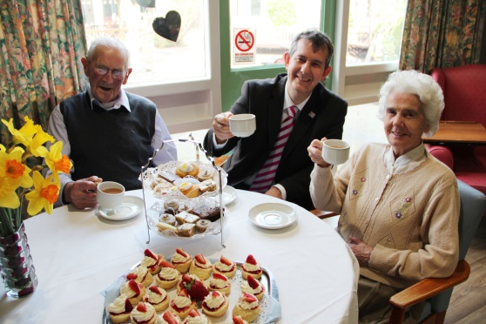
Northern Ireland Health Minister Edwin Poots joining in 2014

Screen it Out

Screen it out is a quick measurement you can do during the week to help educate and remind people of the importance of nutritional screening

- Check up to five sets of patient/resident records and ask the following question:
- Has a nutritional screening been completed within 12 hours of admission?
- Using a simple excel table how many of the patient records scored a ‘yes’ each day
- Plot the total ‘yes’ per day on a chart
- Repeat each day during Nutrition and Hydration Week
- Review your results. You may want to do this individually or with your team and discuss how well you did

Teamwork – ‘Power of 3’

To take part in our ‘the power of three’ challenge please pull together a team of three (in health : one caterer, one dietitian and one nurse, any grade) (In care : one cook, one care assistant and one member of the management team) and follow one meal as it is prepared in the kitchens (or as it arrives in your hospital) to the return of the (hopefully) empty plate to the kitchens AND record all the barriers and examples of good practice that you observe. Start creating your Power of 3 team now and don’t wait until the week!

Keep it Fluid

- Check 5 patients / residents at risk fluid balance charts per day and check:
- Is fluid input and output recorded in mls?
- Is cumulative fluid balance calculated at least twice daily?

WalkRounds

Leadership WalkRounds are a key tool for enabling chief executives and other leaders to develop an effective resident / customer / patient safety culture.

Talking with your frontline staff about their safety concerns and seeing the issues for yourself will help you to check the safety and reliability of your systems of care. Walk Rounds will also demonstrate your commitment to supporting staff in making resident / customer / patient safety everyone’s top priority.

To add your voice and experience to Nutrition and Hydration Week we are asking you and your executive colleagues to take part in the action.

Chef Event

Hold your own Chef Event to raise the profile of the amazing healthcare chef’s in your organisation/country.

Arrange a ‘cook off’ competition and don’t forget to invite the media.

Nutrition Advocate or Champions

Why not take this opportunity to find a Nutrition Advocate(s) in your organisation?

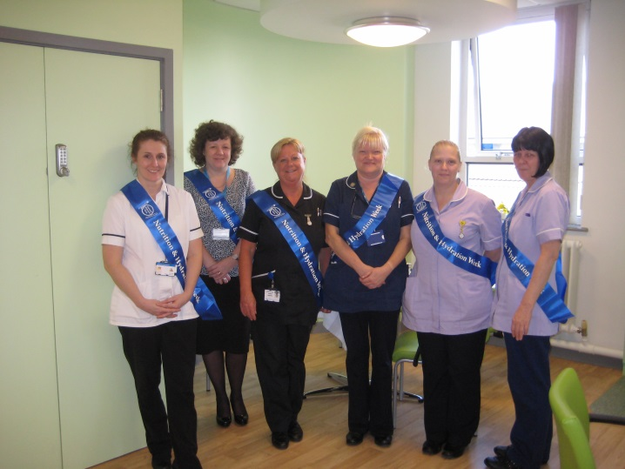
Like the Pennine Health Trust

Develop a Training Opportunity

Why not create a training opportunity to raise awareness during the week by using the Dysphagia Game or the Nutrition Game.

Or just simply make it fun!

For all and promote what you do every day!

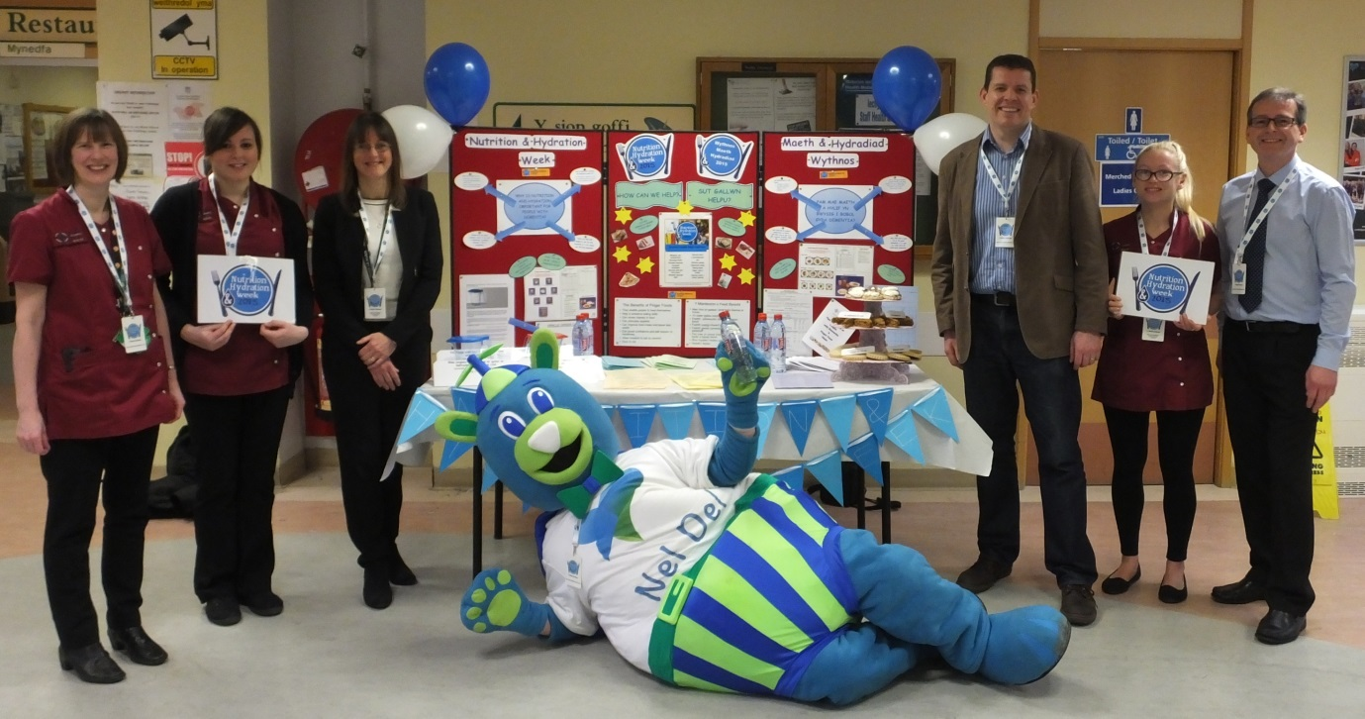

Stay in touch with the Nutrition and Hydration Week Team

N&H Week works best when we all share with each the great stuff we are doing – this is how a true movement is sustained.

The N&H Week team are always keeping an eye out on social media and on email for stories to share with the rest of our community so remember you can get in touch with them in a number of ways:

- Email: nhweek@yahoo.co.uk
- Twitter: www.twitter.com/NHWeek and also the hashtage #NHWeek
- Facebook: www.facebook.com/nhweek
- LinkedIn: http://linkd.in/YhjHDo

Your Nutrition and Hydration Week Planner

Month | Consider | Actions
September | Start planning your activities | Create small working Group
October | Plan Resources | Share plans with senior management
November | Follow @NHWeek on Twitter
December |  | Share initial plans with NH Week
January | Confirm management support & resources | Announce details of your plans
February | Planning photo opportunity | Confirm photographer
 |  | Put up NH Week posters
 | Involve media team | Set twitter feed for your activities
March
Two weeks before |  | Share final plans with NH Week
One week before | Final run through of the events you’ve planned | Confirm Press
 | Final working group meeting to finalise plans
Its here! |  | Tweet, Tell us, Share photos  Promote your work

