Nutrition and Hydration Week
Recipe Book
Over the many Nutrition and Hydration weeks that have been held, many people have generous and shared with us their various recipes.

So we have compiled them into this one recipe book to make it easy for anyone to get hold of them all.

If you have recipes you would like to share and be added to this book, please email them to nhweek@yahoo.co.uk

Enjoy!

Classic Fish and Chip Supper – by Preston Walker

Serves 4
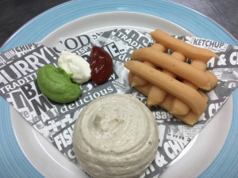

Ingredients

Battered Fish

300g Plain Flour
200g Corn Flour
40g Baking Powder
5g Fine Sea Salt
Ale

100g Plain Flour
4 x 120g Fillets of White Fish (Such as sustainable Cod, Pollock or Colley)
Seasoning

Method

- Mix all the dry ingredients in a bowl.
- Whisk in the Ale until a thick double cream consistency is achieved.
- Taste and season if required
- Set aside the batter until ready to finish.

Chips

400g Peeled Floury Potatoes (cut into chips)

Method

- Heat the frying oil to 150C
- Cook the potatoes in the oil until softened, about 5-10 minutes depending on thickness

Tartar Sauce

100g Mayonnaise
40g Capers (Roughly Chopped)
40g Gherkins (Roughly Chopped)
20g Flat Leaf Parsley (Roughly Chopped)
20g Tarragon (Roughly Chopped)
Juice of a Lemon
Seasoning

Method

- Mix all the ingredients together.
- Taste and season if needed

Minted Pea Puree

400g Frozen Peas (Defrosted)
10 Mint Leaves
100g Water
Seasoning

Method

- Blend all the ingredients together until smooth and silky.
- Pass through a sieve if required.
- Set aside.

To Finish

- Heat the oil in the fryer to 180C.
- Flour the fish fillets, batter and place in the fryer to cook (5-7mins), keep warm.
- Cook the blanched chips in the fryer.
- Heat the pea puree.
- Serve the fish, chips, pea and tartar sauce on warmed plates.

For a puree version:

Fish

4 x Cooked battered fish portions (as above)
200ml Milk
150g Tartar Sauce (as above)
Salt and pepper – to taste
Lemon juice – to taste

- Blend the battered fish with the milk and tartar sauce until smooth
- Pass through a fine sieve to remove any particles
- Season with salt, pepper and lemon juice. Add food thickener, if required.

Chips

400g Mashed potato
80g Tomato ketchup
20ml Malt vinegar
Salt and Pepper – to taste

- Combine all ingredients and season to taste

Rutland Sausage with Bubble and Squeak and Fried Egg – by Preston Walker

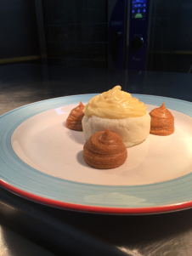
Ingredients

Serves 4

8 Rutland Sausages

400g Buttery Mashed Potatoes
25g Unsalted Butter
50g Diced Carrot
50g Diced Celery
100g Shredded Savoy Cabbage
2 Crushed Garlic Cloves
Salt and Pepper to taste
20g Chopped Flat Leaf Parsley

25g Unsalted Butter

Oil
4 Large Free Range Eggs

Bubble and Squeak

- Heat the butter in a pan.
- Add the carrot and celery and cook until soft.
- Add the cabbage and cook for a further 3 minutes until starting to wilt.
- Add the garlic and cook for a further minute.
- Season and add the parsley. Allow to cool.
- Mix in the mashed potato and form into 4 burger shaped patties.

To Finish

- Heat the oven to 170C.
- Fry the sausages in a tablespoon of oil, over a medium heat until brown and transfer to a baking tray and put in the oven for 15 minutes.
- In the same pan add the butter and heat until bubbling.
- Add the four potato patties and cook until browned, turn over and repeat.
- Transfer the patties to the baking tray with the sausages and cook for 10 minutes.
- Clean the pan and when the sausages and Bubble and squeak is cooked, heat the oil and cook the fried eggs to your liking.
- Serve on warmed plates.

For a Puree Version

Pureed Sausage

750g Lincolnshire sausage meat
450ml Bisto Gluten Free Gravy
100g Onion (diced)
20g Tomato purée
Vegetable oil (for frying)
Food thickener (if needed)

Fry the sausage meat with the onion until softened. Add the tomato puree and cook for 3-5 minutes. Add the gravy and simmer for 10 minutes until cooked through. Blend until smooth, pass through a sieve and thicken if required. Season if necessary.

Vegetable Purees

Carrot Puree

300g Carrot (cut to 1cm dice)
50g Unsalted Butter
Seasoning
Food Thickener (If required)

Cook the carrots until soft in the butter and seasoning. When done blend until smooth, thicken if required and taste.

Celery Puree

200g Celeriac (Cut to 1cm dice)
100g Celery (Cut to 1cm dice)
200g Double Cream
Seasoning
Food Thickener (If required)

Cook the celeriac and celery in the cream and seasoning until soft. Blend until smooth, thicken if required and taste.

Savoy Cabbage Puree

300g Savoy Cabbage (Use only the lighter green leaves and slice thinly)
50g Unsalted Butter
Seasoning
Food Thickener (If required)

Blanch the cabbage leaves in boiling salty water for a couple of minutes until soft then refresh in cold water. Heat the butter and seasoning and bring the cabbage back to temperature. Blend until smooth, thicken if required and taste.

Mashed Potatoes

Buttery mashed potatoes, as above

Egg Puree (Emulsion)

3 Egg Yolks
300g Clarified Butter
Salt

Whisk the egg yolks in a bowl and set over a Bain Marie. When they have thickened slightly add the clarified butter a drop or two at a time. Once the mixture thickens considerably add the butter in a trickle until the mixture becomes thick. Season with salt to taste.

To Plate

Use an oiled ring mould and pipe the potato into the base in the centre of the plate. Remove the ring and pipe dots of carrot, celeriac and cabbage on top.
Pipe 3 larger dots of sausage evenly around the potato at 12, 4 and 8 (point on a clock) and top with the egg emulsion.

Mac and Cheese Bolognaise Bake – by Preston Walker

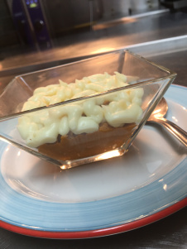
Serves 6

Bolognaise Sauce

15ml Olive Oil
100g Smoked Streaky Bacon
500g Beef Mince
5 Crushed Garlic Cloves
800g Tinned Tomatoes
2 Sprigs of Thyme
Seasoning

Mac and Cheese

100g Dried Macaroni (Cooked in Seasoned Water)
25g Unsalted Butter
25g Plain Flour
600g Whole Milk
150g Mature Cheddar (Grated)
150g Smoked Applewood (Grated)
Salt and Pepper to taste

To Finish

100g Mature Cheddar (Grated)

Method

For the Bolognaise

- Heat the oven to 170C.
- On the stove heat the oil in a heavy based Casserole.
- Slice the bacon finely and fry in a heavy based casserole until crispy and brown, remove from the pan.
- Add the beef mince, season and cook until brown.
- Return the bacon and add the crushed garlic. Cook for a couple of minutes without colouring.
- Add the tomatoes and break the pieces up if required.
- Add the thyme sprigs and season.
- Place the lid on the casserole and put in the oven for 90mins or until the meat has softened and the sauce thickened.
- Season to taste if required.

For the Mac and Cheese

- Heat the butter and flour in a heavy based pan and cook for a couple of minutes.
- Whisk the milk in slowly until a sauce consistency is achieved.
- Add 150g of the Cheddar and Applewood and whisk until it melts.
- Stir in the cooked Macaroni

To Finish

- Pour the Mac and Cheese over the Bolognaise in the casserole
- Sprinkle the remaining cheese over the top and bake in the oven until heated through and brown on top.

For a puree version:

Mac and Cheese Puree

50g Butter
50g Flour
1000g Whole Milk
300g Mature Cheddar
200g Smoked Applewood

Make the cheese sauce as in the recipe above. The sauce will be texture ‘C’ Dysphagia descriptor at serving temperature. If it needs any extra thickening food thickener can be added in to thicken.

Bolognaise Puree

Make as above and blend to a smooth puree consistency. Taste and add any further seasoning and a squeeze of lemon juice if required. Add food thickener until correct consistency is reached.

To Finish

Pipe the Bolognaise puree into a glass/serving dish. Then pipe small arc shapes on top to give the effect of macaroni.

Serve with a puree salad using Avocado, Cucumber, Rocket and Lemon juice

Ciabatta Pizza
Contributed by John Joyce
For 2 people

Ingredients
- 1 ciabatta bread
- any leftover cheese
- packet of pepperoni
- 2-3 tomatoes
- 1tbsp tomato puree
- fresh basil
- 1tbsp olive oil

Method
- Preheat the oven to 200c.
- Cut the ciabatta in half lengthways.
- Spread the tomato puree over the tops of the ciabatta.
- Crumble or grate the cheese over the puree.
- Slice the tomatoes & add on top of the cheese.
- Add slices of pepperoni to suit your taste.
- Drizzle over the olive oil.
- Finally add the chopped basil.
- Bake in the oven for 10 – 12 minutes.
Enjoy.

Avocado & Egg topped with Bacon

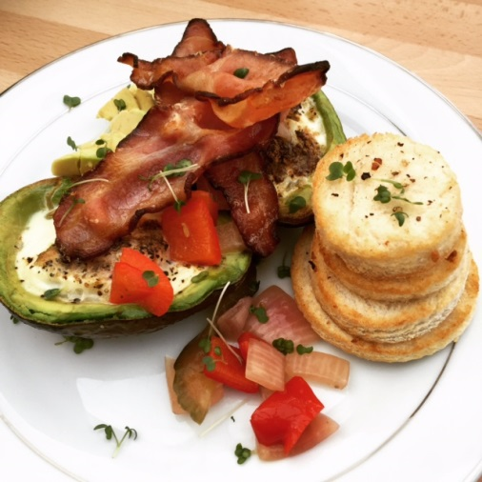
As a Carer and working full time, fresh food plays an important part of my day. It’s important that my meals are simple and nutritional. This recipe can be used as a breakfast, lunch or even a light evening meal.
Ingredients
avocado, halved and pitted
2 eggs
salt and ground black pepper to taste
1 pinch cayenne pepper
3-4 slices of bacon (I use oak chipped bacon from Wilkinsons butchers Blackpool)
1 tablespoon chopped fresh chives
Method
Preheat oven to 425f/220c/gas mark 7
Scoop out enough of the flesh from the avocado, you will use this at the end to dress your plate. Place each avocado half in a ramekin. Crack 1 egg into each avocado half; season with salt, black pepper, and cayenne pepper. Place ramekins on a baking sheet.Bake in the preheated oven until entire egg is cooked through, about 15 minutes. On another baking sheet place your bacon and add this to the oven as well. Get your plates ready and in around 15 minutes the avocado and bacon should be done. Remove from the oven and sprinkle over your chopped chives, avocado flesh and Enjoy!
Feel free to join my Simple fresh food ethos at the following links:
https://www.facebook.com/IceColdChef/

