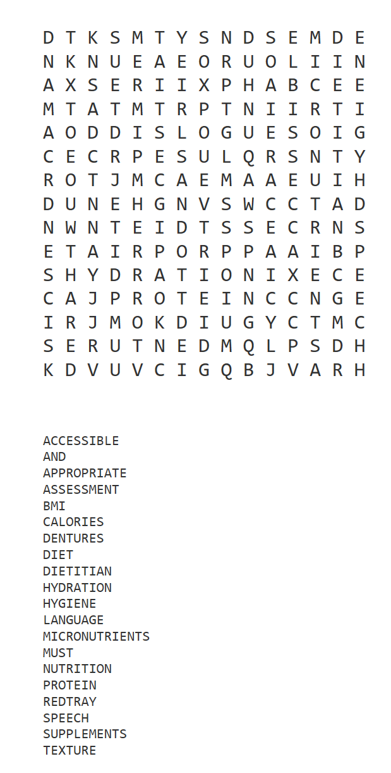
D T K S M T Y S N D S E M D E
N K N U E A E O R U O L I I N
A X S E R I I X P H A B C E E
M T A T M T R P T N I I R T I
A O D D I S L O G U E S O I G
C E C R P E S U L Q R S N T Y
R O T J M C A E M A A E U I H
D U N E H G N V S W C C T A D
N W N T E I D T S S E C R N S
E T A I R P O R P P A A I B P
S H Y D R A T I O N I X E C E
C A J P R O T E I N C C N G E
I R J M O K D I U G Y C T M C
S E R U T N E D M Q L P S D H
K D V U V C I G Q B J V A R H

ACCESSIBLE
AND
APPROPRIATE
ASSESSMENT
BMI
CALORIES
DENTURES
DIET
DIETITIAN
HYDRATION
HYGIENE
LANGUAGE
MICRONUTRIENTS
MUST
NUTRITION
PROTEIN
REDTRAY
SPEECH
SUPPLEMENTS
TEXTURE

