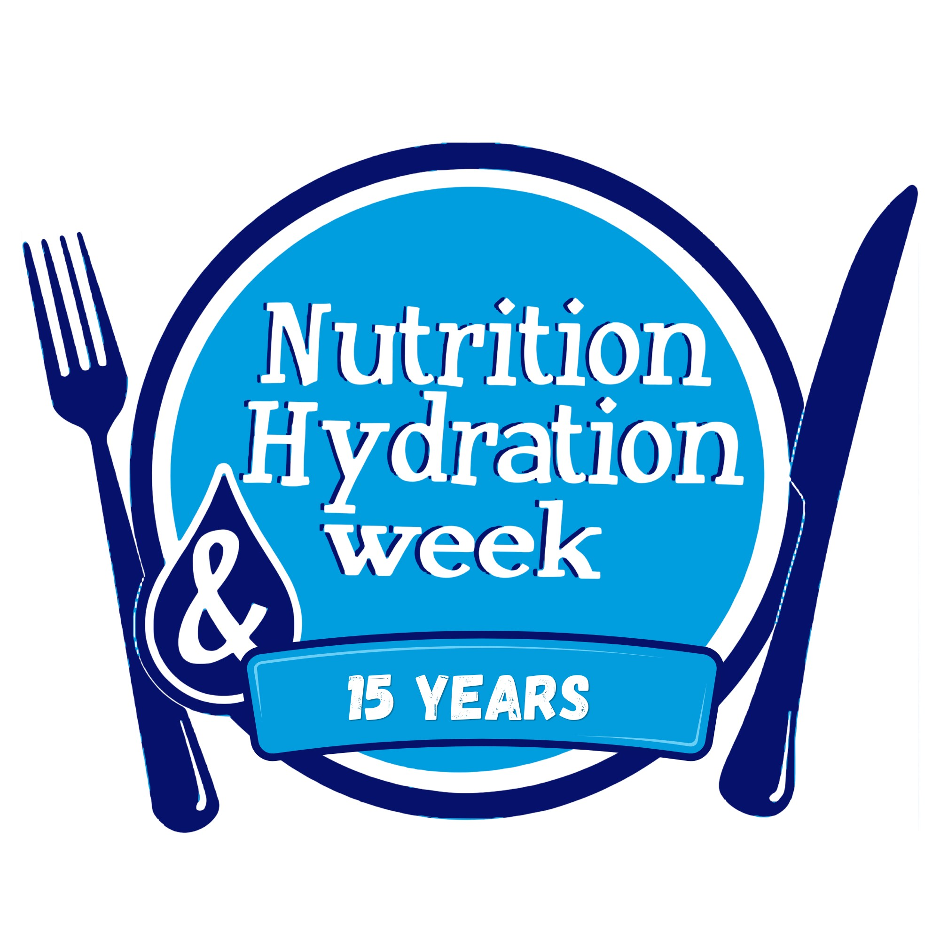
NUTRITION AND HYDRATION WEEK
15th BIRTHDAY SCONE COMPETITION
ENTRY FORM
REMEMBER THE MAIN RULE – HAVE FUN – ENJOY – BE CREATIVE!
Closing date for entries: Wednesday 18th November 2026 | Email: nhweek@yahoo.co.uk
1. ENTRANT DETAILS

Name of entrant: | Organisation / workplace: (if applicable)
Job title / role: | Telephone number:
Email address: | Organisation address: (if applicable)

2. COMPETITION CLASS

Tick entry | Class of scone
☐ | Class One – Sweet Scone
☐ | Class One – Savoury Scone
☐ | Class Two – Allergen-Free Sweet Scone
☐ | Class Two – Allergen-Free Savoury Scone
Please enter one recipe per entry form. If submitting more than one recipe, please complete a separate form for each entry. Please tick one class only. Class Two entrants should complete Section 5 in full.

3. RECIPE INFORMATION

Recipe name: | Number of scones recipe makes:
Short description of the scone:

Suggested serving / accompaniments:

Ingredient | Quantity (g / ml) | Cost (£) | Notes
Total recipe cost: £______________ Cost per portion: £______________ (costs will not be judged – for reference only)
4. METHOD

Please provide a clear step-by-step method, including preparation, mixing, shaping, cooking temperature and cooking time.

Oven temperature (°C) and type (fan / conventional): | Cooking time (minutes): | Resting / cooling time (if any):

5. ALLERGEN INFORMATION

For Class Two entries, please provide details demonstrating how the recipe meets the competition requirements. Please also identify any relevant allergens and explain how cross-contamination is controlled.
Tick every allergen contained in your recipe, including any in shop-bought ingredients (please check the labels). Use the Details column to note how it is used or controlled.
Allergen (put a cross in the box if present in recipe) | Details / controls
☐ Celery
☐ Cereals containing gluten (wheat, rye, barley, oats)
☐ Crustaceans (e.g. prawns, crab, lobster)
☐ Eggs
☐ Fish
☐ Lupin
☐ Milk
☐ Molluscs (e.g. mussels, oysters, squid)
☐ Mustard
☐ Peanuts
☐ Sesame
☐ Soybeans
☐ Sulphur dioxide / sulphites (over 10mg/kg or 10mg/L)
☐ Tree nuts (e.g. almonds, hazelnuts, walnuts, cashews, pecans, pistachios, macadamia, Brazil nuts)

Cross-contamination controls (e.g. separate equipment, preparation area, storage):

6. CREATIVITY & INNOVATION

What makes your scone innovative, creative or different?

7. PRESENTATION

Please describe how you would present and serve your scone to the judges.

8. PHOTOGRAPH

Please attach or insert a clear photograph of your completed scone. Please ensure the photograph shows the finished product clearly. If you are emailing your entry, you can insert the photo here or attach it as a separate JPG or PNG file.
[ INSERT PHOTOGRAPH HERE ]

9. ENTRANT DECLARATION

I confirm that the information provided in this entry form is accurate and that my recipe meets the requirements of the competition class entered.
☐ I am happy for my name, organisation and photograph to be used to promote the competition and Nutrition and Hydration Week.
Name: | Date:
Signature:

10. SUBMISSION

Please submit your completed entry form together with your recipe and photograph by the closing date of Wednesday 18th November 2026.
Email entries to: nhweek@yahoo.co.uk
Before you submit, please check:
☐ One competition class ticked, and one recipe per form
☐ Ingredients, method and allergen information completed (Section 5 in full for Class Two)
☐ Photograph inserted or attached
☐ Declaration completed
Nutrition and Hydration Week – 15th Birthday
nutritionandhydrationweek.co.uk

